SAFETY – METAL L0
NAME:
(Safety quiz will be based 100% on THESE NOTES, plus MACHINE DEMOS)
NAME | PURPOSE, TIPS, SAFETY, & THINGS TO LOOK OUT FOR
BEHAVIOUR | - No _______________  - No _______________  - No _______________
- No _______________ noise

- Pay _______________ to others

ATTIRE | - No _______________  - No ______________ ________________
- No ___________ _______________

- Wear __________ ___________ _________

PROCEDURAL | - Work _______________ & _______ ________  - No _______________
- Ask for _______________ or _______________

- _______________ or _______________ the machine

- Stand ___ ______ _______ away

- Keep fingers ____ _____ _______ away from cutters

SAFETY EQUIPMENT | THE #1 MOST IMPORTANT:  - _______________
- _______________

- _______________

TOOLS
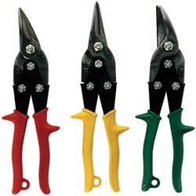  NAME: _______________ | - For cutting __________ __________  - Serrated ______________  - GREEN cuts __________  - YELLOW cuts __________  - RED cuts __________
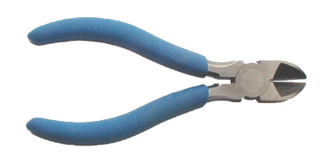  NAME: ________________ | - For cutting ______________
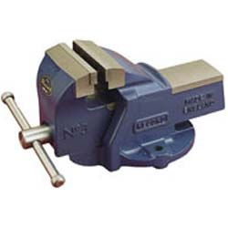  NAME: ________________ | - For ______________ your project  - ______________ will damage the surface
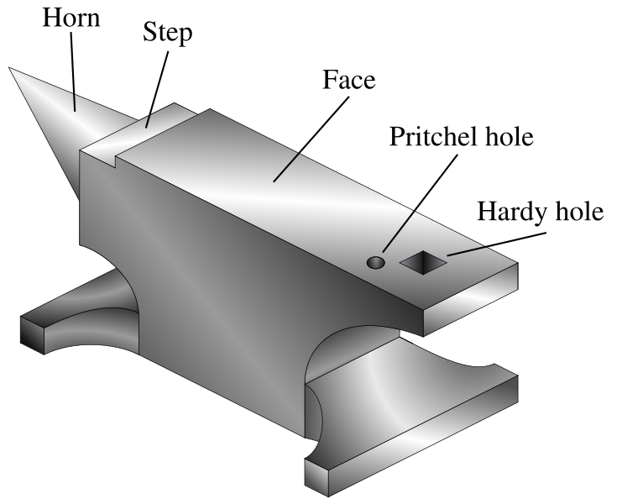  NAME: ________________ | - For ______________ or ______________ metal  - Best for _____________ - _______________
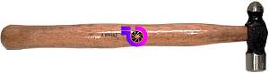  NAME: ________________ | - For ______________ and ______________  - ______________ steel  - Wear ______ ____________
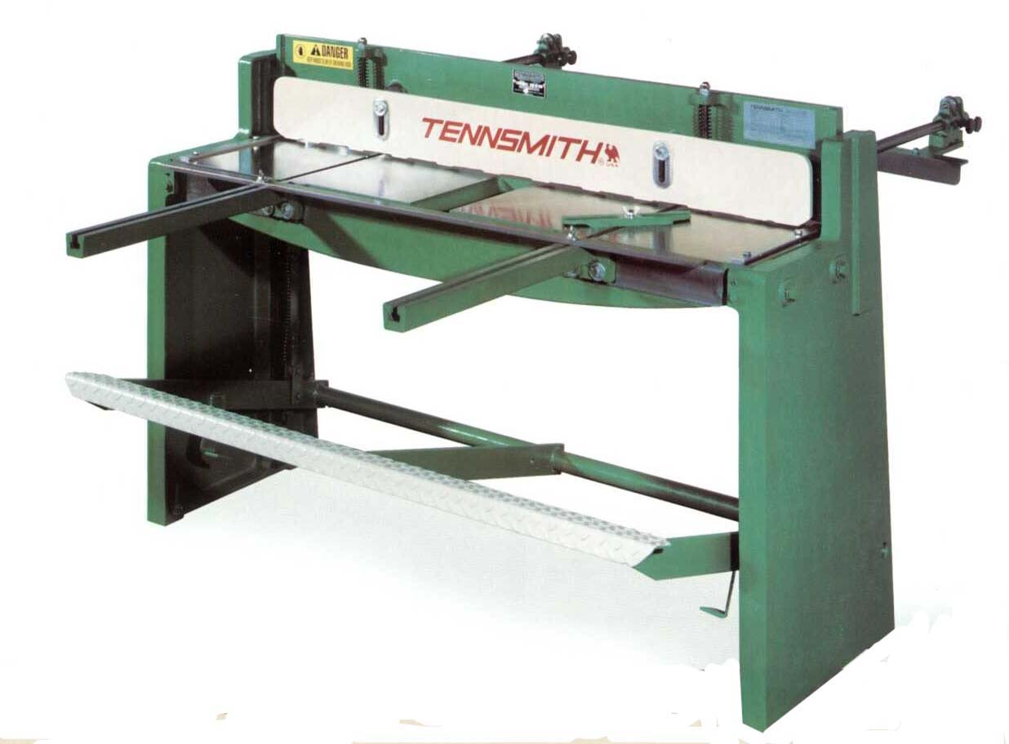  NAME: ________________ | - For cutting ___________ ___________ only
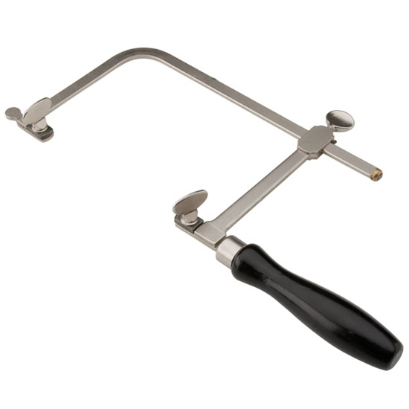  NAME: _________________ | - __________ the blade!  - Teeth point __________ the handle
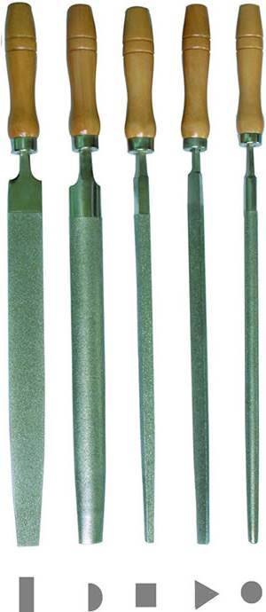  NAME: ________________ | - For ______________ metal  - Easily ___________, ___________ or broken  - Works on the ______________ stroke
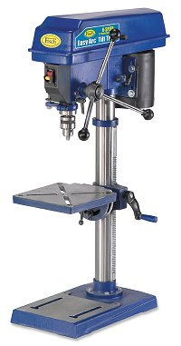  NAME: ________________ | - Makes ___________________  - Wear ___________________  - All material must be __________ ______________
- All holes must be __________ - ________________

- Any hole bigger than 1/4" must be ______ - _________
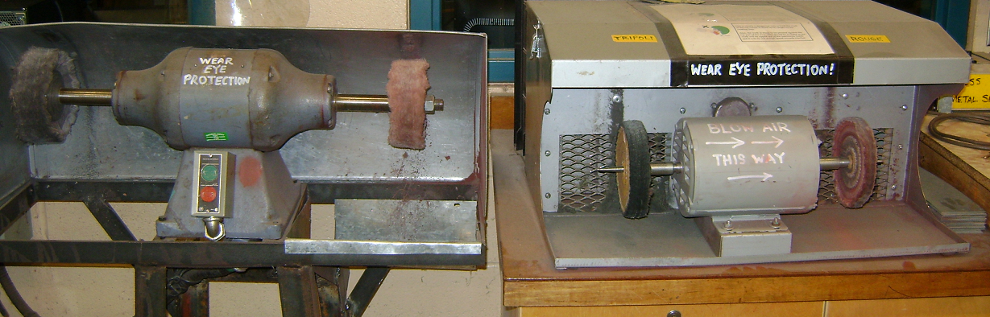  NAME: ________________ | - Wear _______________________  - Polish on the ___________________ of the wheel  - CAUTION: Polishing gets ___________________  - NO ___________________________ !
NAME: _________________  Vernon BC, 2019:  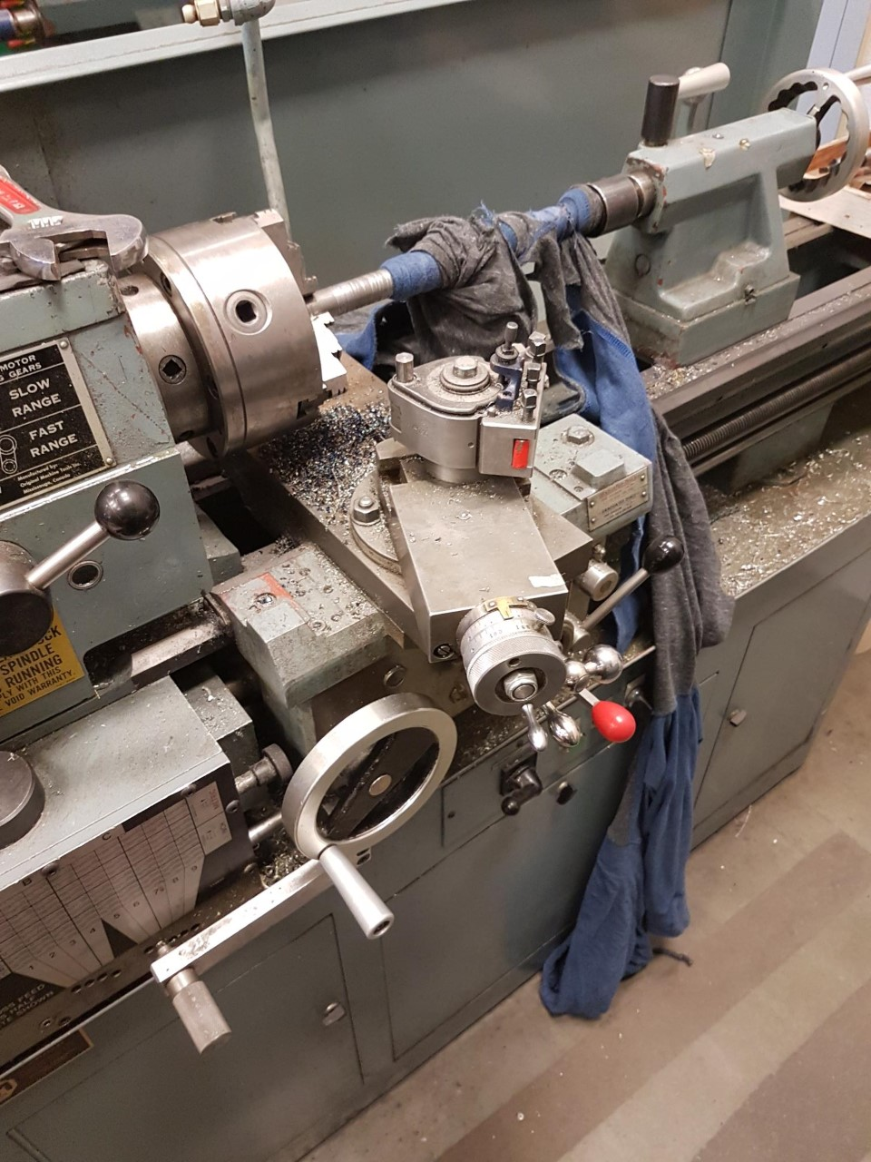  (Continued) | 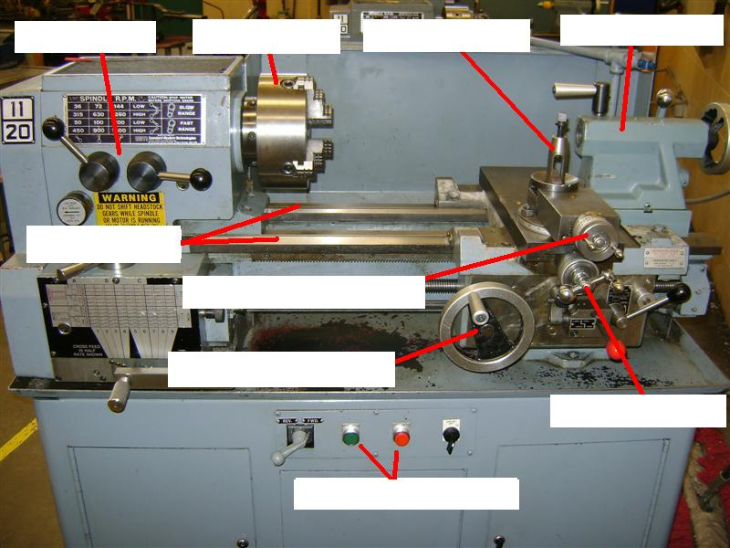
- Makes things ____________________

- Wear ________ ____________________

- Keep hands, arms, sleeves, and hoodie strings away from the _______ _________ ___________from the spinning chuck

- IT WILL MESS YOU UP

- Be nice to the cutter - take __________ cuts.

- Never leave the ________ _________ in the chuck!

- Spin the chuck _______ ___________ before you turn it on
(Continued) | - Cutter travel should be __________ to travel  - Cutting tip should be the same height as the ______________ ________________________  - CROSS OUT the two WRONG CUTTER HEIGHT setups:  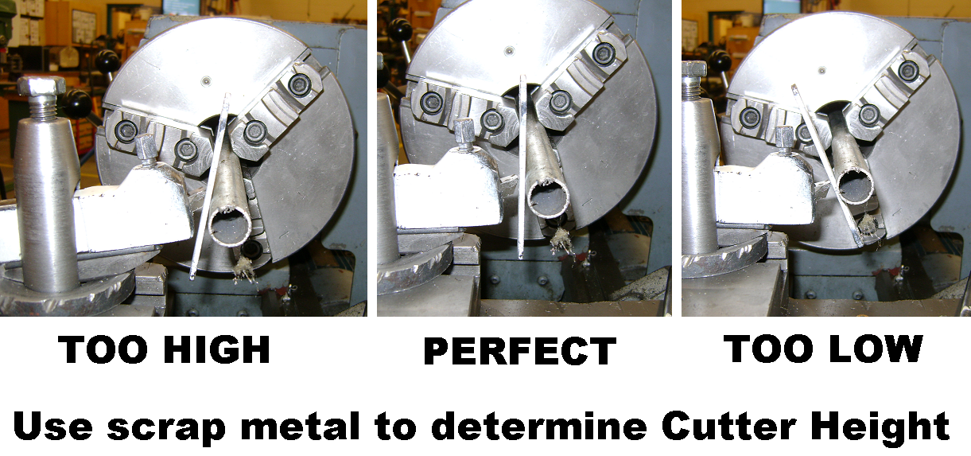
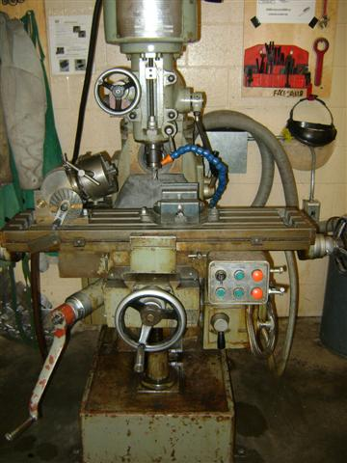NAME: _________________ | - Makes things _________________  - Wear ________ ______________
- Material must be ________ __________________

- Keep hands, arms, sleeves, and hoodie strings away from the ________ __________ from the spinning cutter

- It WILL mess you up

- Cut ___________________ the rotation of the cutter

- Be nice to the cutter - take light cuts.

- Draw the direction arrows correctly:

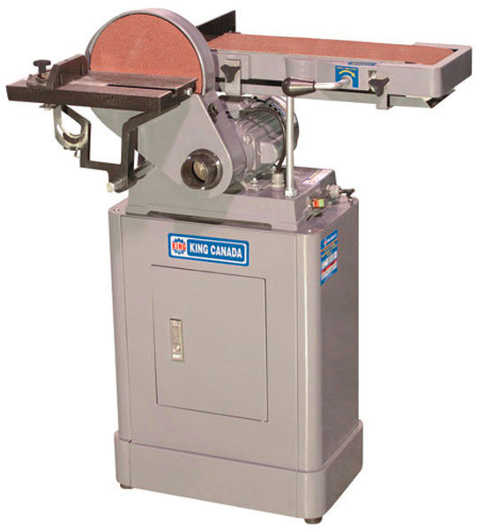  NAME: _________________ | - For ___________________ metal surfaces  - ________ ________________  - Watch your ____________________  - Sand on _______________ side of disc rotation
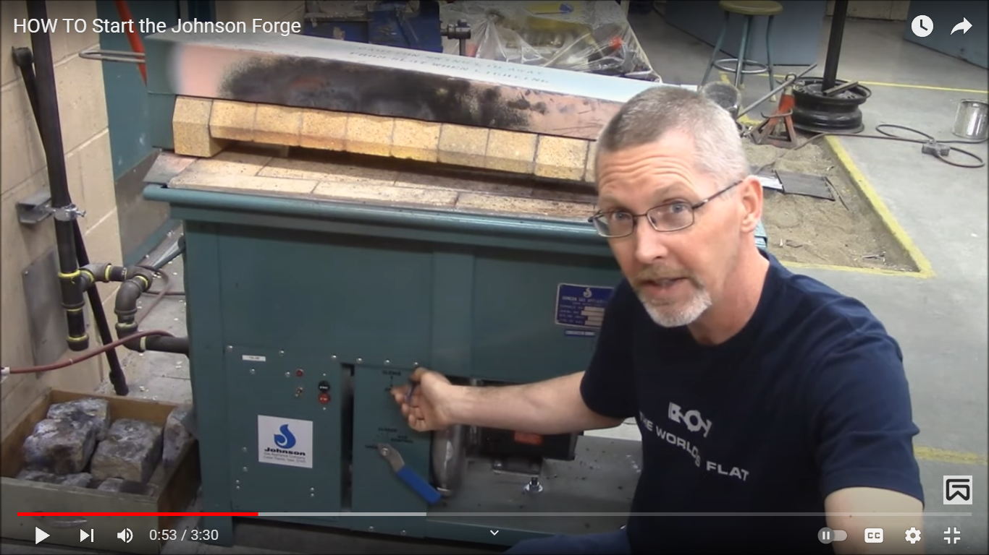  NAME: _________________ | - __________________!  - __________________ __________________!  - __________________ __________________!  - __________________ __________________!  - __________________ __________________!  - __________________!

